1. What is econ?

Study of people and their choices

1. Types of Costs
2. Cost Benefit relation
3. Macro vs micro econ
4. communism/socialism v/s. Capitalism —-> mixed econ

**Topics :**

Informal Economy and Role of Marketing

AI and its Role in consumer behavior

Social media listening - an economic review

Consumer Behavior and sales performance

Celebrity marketing - an economic review

2023 banking crisis

the economic impact of Fintech on Asian Countries

Economic review of the 4 day work week policy

Brand loyalty in developing countries

Supply chain security and influence on marketing

Digital marketing and behavioral economics

Inspire from research gaps

**Title:**

Impact of AI on consumer behavior

AI Marketing; Understanding the needs and preferences of the consumer

• AI Marketing, AI-Based Promotions, and the threat to consumer autonomy

• AI Marketing predictions the purchasing behavior of their target customer

• AI Marketing and customer engagement

• AI Marketing and customer well being

• Consumer trust due to AI innovation in digital marketing

• Consumer familiarity with AI in digital marketing and purchase process

• Marketing automation technology, AI and promotions, and influence on consumer behavior

• Channel and time optimization: Delivering messages through the suitable medium at the right time to the right customer

• Ensuring accurate data matching when combining internal and external consumer informationTypologies of customers (or potential customers) that benefit most from AI Marketing and consumers who will be adversely impacted

• AI transformation of the luxury industry – consumer behavior of luxury digital platforms of both fashion and hospitality services.

Research question:

1. Evaluating the Effectiveness of generative ai in Consumer Behavior

**Bard :**

Sure, here is a research proposal for the question: Evaluating the Effectiveness of Generative AI in Consumer Behavior.

Introduction

Generative AI is a type of artificial intelligence that can create new content, such as text, images, and music. This technology has the potential to revolutionize the way businesses interact with consumers. For example, generative AI can be used to create personalized marketing campaigns, generate product recommendations, and even create customer service chatbots.

Literature Review

There is a growing body of research on the effectiveness of generative AI in consumer behavior. Some studies have found that generative AI can be effective in increasing customer engagement and conversion rates. For example, one study found that a chatbot powered by generative AI was able to increase customer engagement by 20%. Another study found that a personalized marketing campaign that used generative AI was able to increase conversion rates by 15%.

Research Questions

This research will investigate the following research questions:

1. How effective is generative AI in influencing consumer behavior?
2. What are the different ways that generative AI can be used to influence consumer behavior?
3. What are the factors that influence the effectiveness of generative AI in influencing consumer behavior?

Methods

This research will use a mixed-methods approach. A survey will be used to collect data on consumer attitudes and behavior toward generative AI. A case study will be used to investigate how generative AI has been used to influence consumer behavior in a real-world setting.

Expected Results

This research is expected to provide new insights into the effectiveness of generative AI in influencing consumer behavior. The findings of this research will be of interest to businesses that are considering using generative AI to improve their marketing and customer service efforts.

Conclusion

Generative AI is a powerful new technology that has the potential to revolutionize the way businesses interact with consumers. This research will investigate the effectiveness of generative AI in influencing consumer behavior. The findings of this research will be of interest to businesses that are considering using generative AI to improve their marketing and customer service efforts.

**GPT :**

Title: Evaluating the Effectiveness of Generative AI in Influencing Consumer Behavior: A Comprehensive Research Proposal

1. Introduction:

Generative Artificial Intelligence (AI) has emerged as a powerful tool in various domains, including marketing and advertising. By leveraging generative AI algorithms, businesses can create personalized and engaging content to influence consumer behavior. This research proposal aims to evaluate the effectiveness of generative AI in influencing consumer behavior and explore its potential implications for businesses in terms of customer acquisition, retention, and overall marketing performance.

2. Research Objectives:

The primary objectives of this research are as follows:

a. To assess the impact of generative AI-generated content on consumer attitudes and purchase intentions.

b. To evaluate the influence of generative AI-driven personalized recommendations on consumer decision-making processes.

c. To identify the underlying mechanisms through which generative AI impacts consumer behavior, such as perceived relevance, trust, and emotional engagement.

d. To investigate potential ethical concerns associated with the use of generative AI in consumer behavior influence.

3. Methodology:

a. Experimental Design: Conduct a controlled experiment where participants are exposed to marketing stimuli, such as ads, product recommendations, or social media content. The stimuli will be generated using both generative AI algorithms and human efforts, ensuring a balanced representation across different groups.

b. Data Collection: Employ a mixed-methods approach, combining quantitative data collection techniques (e.g., surveys, behavioral tracking) and qualitative methods (e.g., interviews, focus groups) to gather comprehensive insights into consumer behavior and perceptions.

c. Sample Selection: Recruit a diverse sample of participants representing the target market of interest. Ensure an appropriate sample size to achieve statistical significance and consider factors such as demographics, prior purchase behavior, and technology adoption.

d. Experimental Duration: Implement the study over a defined period, such as several weeks, to capture sufficient data points and account for potential temporal effects.

e. Data Analysis: Utilize statistical analyses, such as regression models, ANOVA, and correlation analyses, to examine the relationship between generative AI-generated content and consumer behavior outcomes. Conduct thematic analysis for qualitative data to identify emerging patterns and themes.

4. Expected Outcomes:

a. Quantitative Analysis: Determine the impact of generative AI-generated content on consumer attitudes, purchase intentions, and actual purchase behavior. Explore the moderating effects of variables like personalization, content relevance, and trust.

b. Qualitative Analysis: Uncover the underlying mechanisms through which generative AI influences consumer behavior, including perceived relevance, trust in AI recommendations, emotional engagement, and cognitive processes.

c. Ethical Considerations: Investigate potential ethical concerns associated with generative AI in consumer behavior influence, such as privacy issues, algorithmic biases, and transparency. Provide recommendations for responsible AI implementation in marketing.

d. Managerial Implications: Generate practical insights and recommendations for businesses on effectively utilizing generative AI to influence consumer behavior, including strategies for content personalization, targeting, and ethical guidelines.

5. Implications and Applications:

a. Theoretical Contributions: Contribute to the existing literature on AI and consumer behavior by providing empirical evidence on the effectiveness of generative AI in influencing consumer attitudes, decision-making, and purchase behavior.

b. Practical Implications: Offer insights into how businesses can leverage generative AI technologies to enhance their marketing strategies, customer acquisition, and retention efforts.

c. Ethical Considerations: Highlight the ethical challenges associated with generative AI-driven consumer behavior influence and provide recommendations for ensuring transparency, fairness, and user consent.

d. Policy Recommendations: Inform policymakers and regulatory bodies about the potential impact of generative AI on consumer behavior and the need for guidelines and regulations to protect consumer rights.

6. Conclusion:

This research proposal aims to evaluate the effectiveness of generative AI in influencing consumer behavior and provide insights into

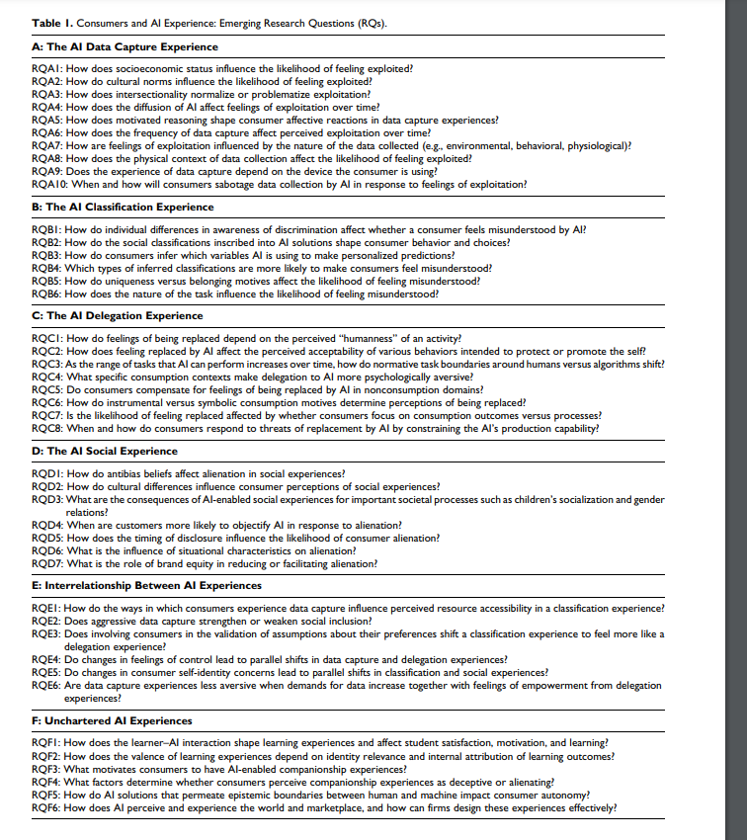

Analysis framework :

Sure, here is an analysis framework that can be used to study the effectiveness of generative AI in consumer behavior:

**1. ** Identify the specific generative AI techniques that are being used.

There are a variety of generative AI techniques that can be used to influence consumer behavior. Some of the most common techniques include:

* Natural language processing: This technique can be used to generate personalized text content, such as product descriptions, marketing copy, and customer service responses.
* Image generation: This technique can be used to generate personalized images, such as product renders, marketing images, and user avatars.
* Audio generation: This technique can be used to generate personalized audio content, such as product demos, marketing videos, and customer support recordings.

**2. ** Determine how these techniques are being used to influence consumer behavior.

Generative AI techniques can be used to influence consumer behavior in a variety of ways. Some of the most common ways include:

* Personalization: Generative AI can be used to personalize the customer experience, such as by recommending products that are likely to be of interest to the individual consumer.
* Engagement: Generative AI can be used to create engaging and interactive experiences, such as by generating personalized chatbots that can answer customer questions and provide support.
* Conversion: Generative AI can be used to increase conversion rates, such as by generating personalized landing pages that are more likely to lead to sales.

**3. ** Measure the effectiveness of these techniques.

The effectiveness of generative AI techniques can be measured in a variety of ways. Some of the most common metrics include:

* Conversion rates: This metric measures the percentage of visitors who take a desired action, such as making a purchase or signing up for a newsletter.
* Customer satisfaction: This metric measures how satisfied customers are with the products, services, and experiences that they receive.
* Brand awareness: This metric measures how aware consumers are of a brand and its products or services.

**4. ** Identify the challenges and limitations of using generative AI in consumer behavior.

There are a number of challenges and limitations that need to be considered when using generative AI in consumer behavior. Some of the most common challenges include:

* Bias: Generative AI techniques can be biased, which can lead to unfair or inaccurate results.
* Privacy: Generative AI techniques can collect and use a lot of personal data, which can raise privacy concerns.
* Explainability: It can be difficult to explain how generative AI techniques work, which can make it difficult to trust the results.

**5. ** Make recommendations for how marketers can effectively use generative AI to influence consumer behavior.

Based on the findings of the analysis, the researcher can make recommendations for how marketers can effectively use generative AI to influence consumer behavior. Some of the most common recommendations include:

* Use generative AI to personalize the customer experience.
* Use generative AI to create engaging and interactive experiences.
* Use generative AI to increase conversion rates.
* Be aware of the challenges and limitations of using generative AI.

This is just a framework, and the specific analysis will be determined based on the results of the research. However, this framework provides a general overview of the analysis that can be conducted.